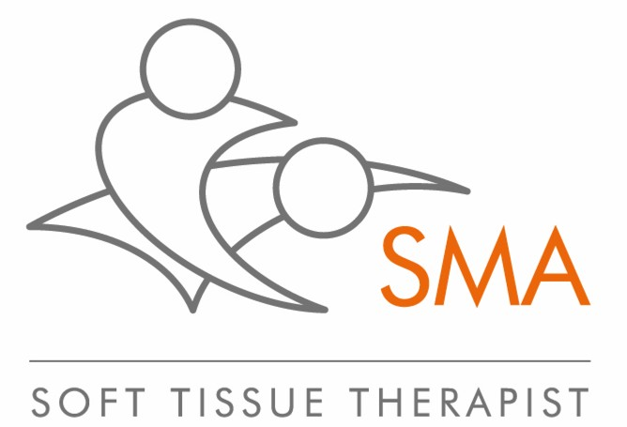
COVID-19 SCREENING AND CONSENT
FULL NAME
DATE OF BIRTH
EMAIL ADDRESS
MOBILE NUMBER
TESTING
Have you had a Covid-19 test? If yes, when? Antigen or antibody test?  Antigen – tests for Covid-19 on day of testing. Antibody – possible immunity |  | YES  Date: | NO
If it was a positive result, has the isolation period expired? |  | YES | NO
Do you still have symptoms? |  | YES | NO
Are you registered with the NHS Test & Trace app |  | YES | NO
SYMPTOMS - Are you experiencing any of the following?
Severe breathing difficulties or chest pain |  | YES | NO
Difficulty in waking or confusion |  | YES | NO
If yes to any of the above call 999
Fever |  | YES | NO
Onset, or worsening of a cough |  | YES | NO
Sore throat or runny nose |  | YES | NO
Chills or headache |  | YES | NO
Pain swallowing |  | YES | NO
Muscle & joint ache |  | YES | NO
Fatigue or exhaustion |  | YES | NO
Loss of taste or smell |  | YES | NO
If any of the above, the advice is to self-isolate for 7 days. A Covid-19 test may be necessary, call 119
Shortness of breath or difficulty lying down due to chest issues |  | YES | NO
If any of the above, call 111
Have you been in contact with anyone with Covid-19 symptoms? |  | YES | NO
Have you recently been hospitalised |  | YES | NO
If so, why:
Do you have any of the following health issues?
High blood pressure or other heart condition |  | YES | NO
Diabetes Type 1 or 2 – if so, which? |  | YES | NO
Cancer |  | YES | NO
Lung condition |  | YES | NO
Any other conditions – please list:
If you have had Covid-19:
Are you experiencing post Covid-19 circulatory complications (deep vein thrombosis, micro-embolisms, stroke symptoms or pulmonary embolism) |  | YES | NO
Are you?
An NHS front line worker |  | YES | NO
A carer – home or care home |  | YES | NO
Shielding a vulnerable adult |  | YES | NO
Pregnant – how many weeks? |  | YES | NO
Aged over 70 |  | YES | NO
Allergic to latex gloves or specific cleaning products |  | YES | NO
SIGNED
I solemnly and sincerely declare that the information I have provided is true and correct and I make this solemn declaration conscientiously believing the same to be true. If any person should suffer as a result of the information being found to be untrue and false, then I am aware I can be prosecuted for making a false declaration.

If either I or someone I have been in contact with tests positive for Covid-19 or have been contacted by NHS Test & Trace I will inform you.

Full name…………………………………………

Date………………………………………………

SMA RESOURCE PACK ADAPTED FROM THE GCMT RESOURCE PACK - ISSUED 08 JUNE 2020

