Consultation Form
Massage Therapy by Nicola Wright

Name: | Mobile Number:
Email: | Occupation:

Do you have or ever suffered from: | Y | N | Details
High or Low Blood Pressure
Circulatory problems
Respiratory problems
Digestive problems (IBS etc)
Heart Condition
Chronic or serious illnesses
Epilepsy
Liver or Kidney complaints
Recent haemorrhage
History of thrombosis or embolism
Diabetes
Are you pregnant, if so, how many weeks?
Any skin disorders or allergies
Are you on any medication?
Any discomfort/pain in your body?
What do you expect from this massage?

May I contact you with the details provided?

Client Declaration

“I, the undersigned have completed the form as fully and as accurate as I can. I believe the details to be correct and consent to having a treatment with Nicola. I release Nicola from the consequences of any negligent misrepresentation that may be contained in this form.”

Client Signature: | Date:
Therapist Signature: | Date:

Area of pain: | 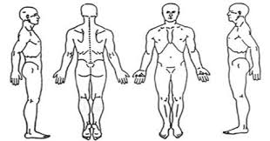
Duration of pain:

Comments:

Appointment Dates/Notes:

